Contact
Kathrin Fleuchaus
Marketing Communications
Coperion GmbH
Theodorstraße 10
70469 Stuttgart/Germany

Telephone +49 (0)711 897 25 07
kathrin.fleuchaus@coperion.com
www.coperion.com

Press Release

Brückner Maschinenbau awards Coperion volume contract
Expansion of partnership between Coperion and Brückner
Stuttgart, August 2025 – Brückner Maschinenbau, the world's leading manufacturer of film stretching lines, has once again awarded Coperion a volume contract for ZSK twin screw extruders of the ZSK Mc¹⁸ series. This order is based on the long-standing, intensive cooperation between Brückner and Coperion, which began back in 2008.
Brückner initially used Coperion ZSK extruders for BOPP film lines. This was followed by numerous projects that the two companies successfully implemented together. In the meantime, the range of applications for film stretching lines has expanded significantly: Brückner also implements lines for BOPET, BSF, and BOPA films with ZSK extruders, among others.
The current volume contract underscores Brückner's confidence in Coperion's proven technology. The ZSK extruders melt the compounds that feed the film stretching lines. Thanks to their high torque, the ZSK Mc¹⁸ extruders achieve very high throughputs while maintaining low product temperatures, resulting in first-class product quality.
“We greatly appreciate the close, constructive cooperation with Brückner Maschinenbau,” says Cornelia Koch, Business Segment Manager Direct Extrusion at Coperion. “Together, we have already successfully completed numerous projects. With the comprehensive expertise of our two companies, we have been able to develop many innovative solutions over the years that have increased the throughput rates of Brückner film stretching lines, boosted their efficiency, and improved film quality.”

About Coperion
Coperion (www.coperion.com) is a global industry and technology leader in compounding and extrusion systems, size reduction, washing, separating, drying, agglomeration, feeding, weighing, material handling and pneumatic conveying systems, as well as milling, mixing, thermal processing, dust collection and other services. Coperion develops, produces, and services plants, machinery, and components for the plastics and plastics recycling, chemical, battery, minerals, food and pharmaceutical industries. Coperion employs more than 5,000 people in its three divisions, Performance Materials, Food, Health & Nutrition, and Aftermarket Sales & Service - at over 50 sales and service locations worldwide. Herbold Meckesheim is a brand of Coperion. Coperion is an Operating Company of Hillenbrand (NYSE: HI), a global industrial company that provides highly-engineered, mission-critical processing equipment and solutions to customers serving a wide variety of industries around the world. www.hillenbrand.com



Dear Colleagues,
You can find and download this press release in German and English and print-ready color images at
https://www.coperion.com/en/news-media/newsroom/
.

Editorial contact and copies:
Dr. Jörg Wolters, KONSENS Public Relations GmbH & Co. KG,
Hans-Böckler-Str. 20, D - 63811 Stockstadt am Main, GERMANY
Tel.: +49 (0)60 27/ 99 00 5-0
E-Mail: mail@konsens.de, Internet: www.konsens.de

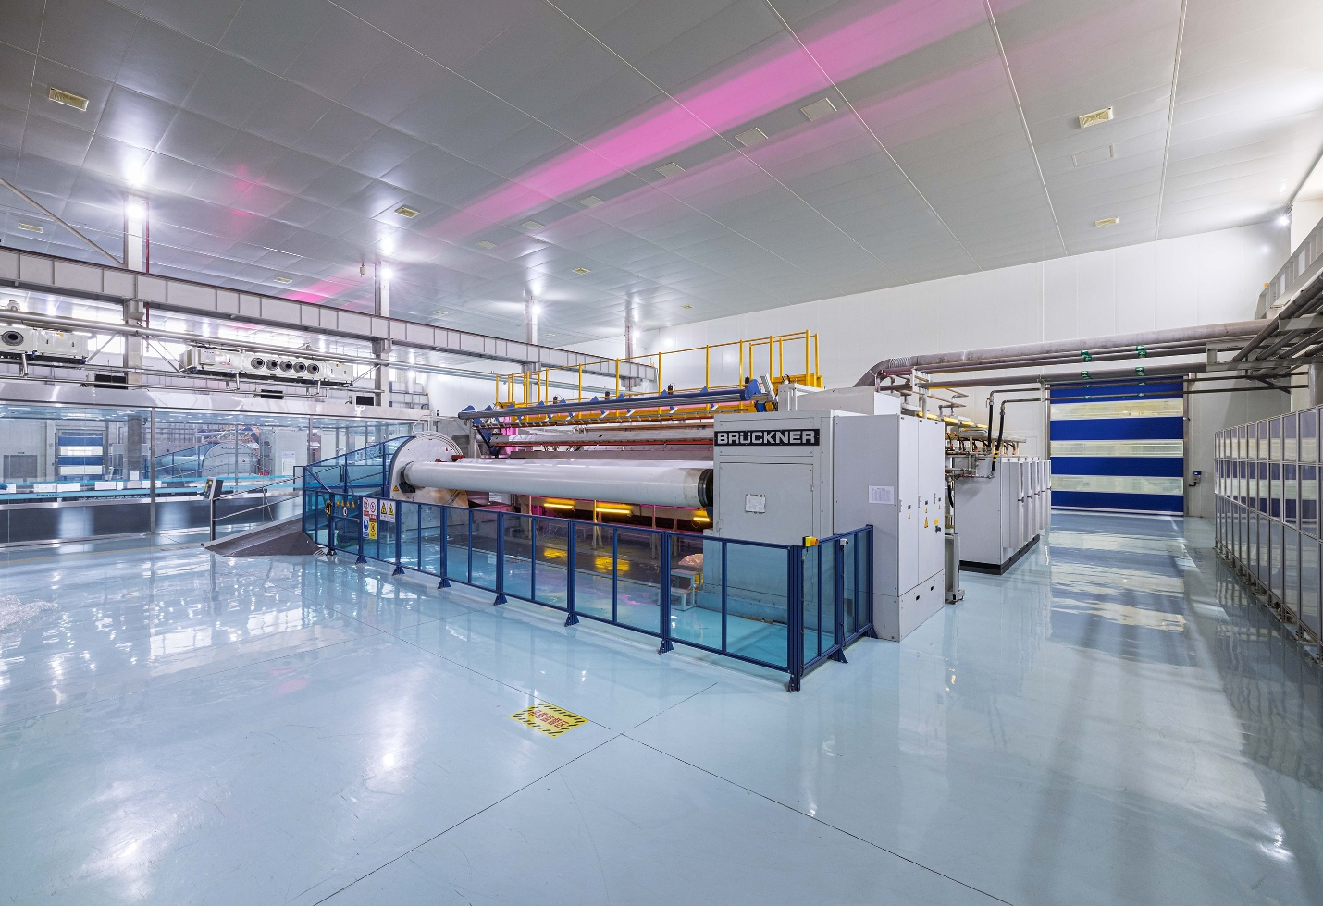
For its plastic film stretching lines Brückner Maschinenbau relies on Coperion ZSK extruders, which melt the raw material.
Image: Brückner Maschinenbau, Siegsdorf/Germany

