Contact
Regula Sullivan
Marketing Communications
Coperion K-Tron (Switzerland) LLC
Lenzhardweg 43/45
CH-5702 Niederlenz

Tel: +41 62 885 7171
regula.sullivan@coperion.com
www.coperion.com
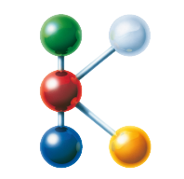

Hall 14 I Booth 14B19
Hall 9 I Booth 9B34
FG/CE07 I Open Area "The Power of Plastics Forum"

Press Release

Coperion at K 2025
Driving Innovation Across the Plastics Industry with Extended Range of Technologies for High-Accuracy Feeding and Weighing
Niederlenz, Switzerland, September 2025 – Coperion will unveil its enhanced portfolio of smart feeding and weighing technologies at K 2025, highlighting the integration of two industry-leading technology brands – Coperion K-Tron and Coperion (formerly Schenck Process FPM) and its AccuRate® and MechaTron® feeding lines. This merger consolidates a comprehensive array of solutions for the plastics industry, providing manufacturers with unparalleled options for feeding and weighing technologies.
Visitors can explore extensive feeding solutions at two dedicated locations: Hall 14 | Booth B19, focusing on Compounding Solutions and the Open Area | FG/CE07, dedicated to Recycling Technology. At both booths, attendees will have the opportunity to engage with Coperion feeding experts and learn about the company’s latest plans to harmonize the expanded feeder product line with the Coperion K-Tron SmartConnex Feeder Control environment. This includes the integration of the newly redesigned KCM-III Control Module and K-Vision Line Controller that offers a variety of connectivity options. Attendees also can learn about the Coperion K-Tron Smart Force Transducer (SFT) weighing technology and how combining digital precision, vibration immunity, and real-time linearization offers exceptional accuracy and reliability.
Feeding Solutions for Compounding Applications
In Hall 14, Booth B19, the focus is on advanced compounding technology. Here, Coperion will demonstrate how its high-accuracy feeders and innovative systems can optimize production processes, improve efficiency, and enhance product quality. Attendees can witness the capabilities of the T35 twin screw feeder, which is ideal for feeding challenging additives. The T35 will be equipped with ActiFlow™ Bulk Solid Activator technology and Electronic Pressure Compensation (EPC). EPC is a smart solution that automatically detects and compensates for pressure changes to ensure reliable weighing performance.
New additions to the Coperion portfolio that will be on display are the economical AccuRate Series 602 volumetric feeder and the MechaTron Coni-Flex single screw feeder that is perfectly suited for either volumetric or gravimetric feeding applications. Both the AccuRate Series and the MechaTron Coni-Flex feeders feature vinyl hoppers that are agitated on the exterior by two paddles. Attendees can also see how the MechaTron’s innovative design allows for complete disassembly without removing upper extension hoppers, bins, bulk bags or IBSs; significantly reducing maintenance time and operational costs.
Another member of the Coperion feeder portfolio in Booth B19 is the ProRate PLUS-MT Twin Screw Feeder that delivers a durable, preconfigured solution for moderate to free-flowing materials, combining proven feeding technology with ease of operation.
Recycling-Focused Feeders Demonstrate Efficiency and Gentleness
In Coperion’s Recycling Pavilion in the Open Area, FG/CE07, the company will highlight its feeding solutions suitable for fragile and challenging materials used in plastics recycling systems. The MechaTron FB Feeder is capable of handling various virgin or recycled materials — including plastics, glass, and carbon fibers, with its flat-bottom design and internal agitation system ensuring optimal mass flow and high-capacity operation.
Another feeder perfect for the plastics recycling industry is the Coperion K-Tron K3-V200 Vibratory Feeder that excels in delivering high-accuracy gravimetric feeding of free-flowing fragile materials such as flakes and glass fibers with gentleness and efficiency. Its innovative drive technology minimizes mechanical wear and energy consumption while facilitating rapid product changeovers with a quick-release tray mechanism.
Last but not least, the tried-and-true S60 single screw feeder will also be on display. Well-suited for handling free-flowing materials like pellets and powders, its modular design ensures durability and hygiene, with straightforward disassembly and easy screw replacement for maintenance convenience. This feeder is available in both volumetric and gravimetric configurations, offering flexible options for recycling and processing applications.
Coperion Performance Materials Division President Markus Parzer says: “The strategic integration of feeding and weighing technologies enables Coperion to offer a broader, more innovative portfolio, empowering plastics manufacturers and recyclers to enhance their processes with reliable, efficient, and scalable solutions. ”
About Coperion
Coperion (www.coperion.com) is a global industry and technology leader in compounding and extrusion systems, size reduction, washing, separating, drying, agglomeration, feeding, weighing, material handling and pneumatic conveying systems, as well as milling, mixing, thermal processing, dust collection and other services. Coperion develops, produces, and services plants, machinery, and components for the plastics and plastics recycling, chemical, battery, minerals, food and pharmaceutical industries. Coperion employs more than 5,000 people in its three divisions, Performance Materials, Food, Health & Nutrition, and Aftermarket Sales & Service - at over 50 sales and service locations worldwide. Coperion is an Operating Company of Hillenbrand (NYSE: HI), a global industrial company that provides highly-engineered, mission-critical processing equipment and solutions to customers serving a wide variety of industries around the world. www.hillenbrand.com



Dear Colleagues,
You can find and download this press release in German and English and print-ready color images at
https://www.coperion.com/en/news-media/newsroom/
.

Editorial contact and copies:
Dr. Jörg Wolters, KONSENS Public Relations GmbH & Co. KG,
Hans-Böckler-Str. 20, D - 63811 Stockstadt am Main, GERMANY
Tel.: +49 (0)60 27/ 99 00 5-0
E-Mail: mail@konsens.de, Internet: www.konsens.de

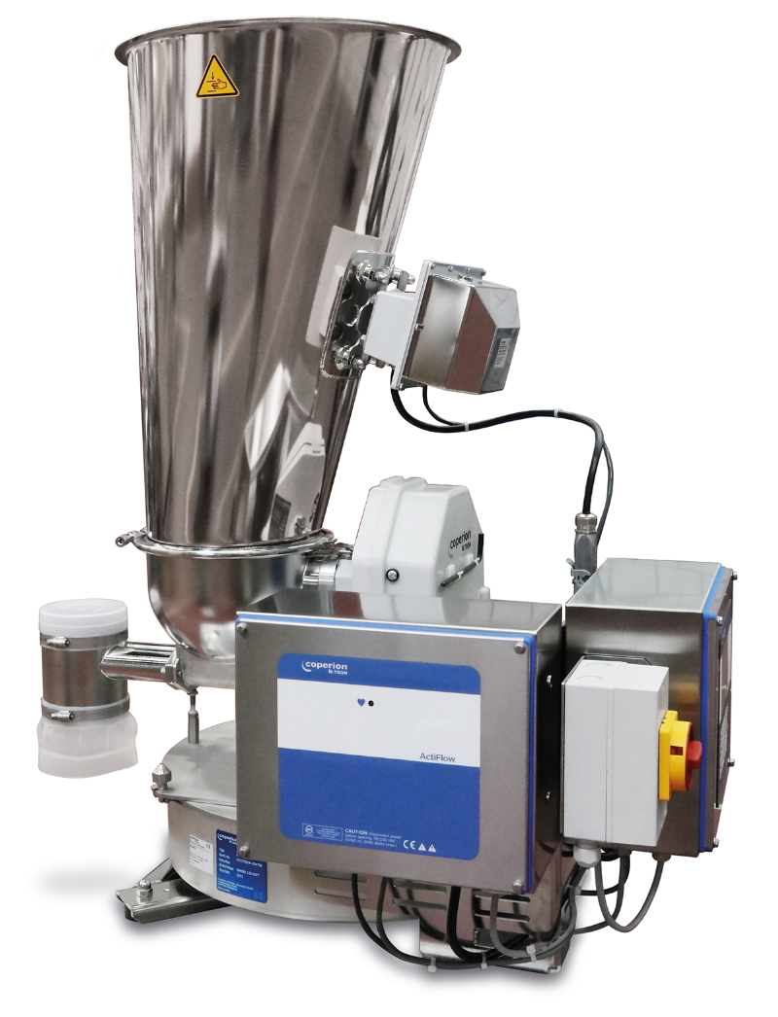
Hall 14 | Booth B19 ─ Coperion K-Tron T35 twin screw feeder shown here with ActiFlow bulk solid activator and KCM-III Controller.
Photo: Coperion K-Tron, Niederlenz Switzerland

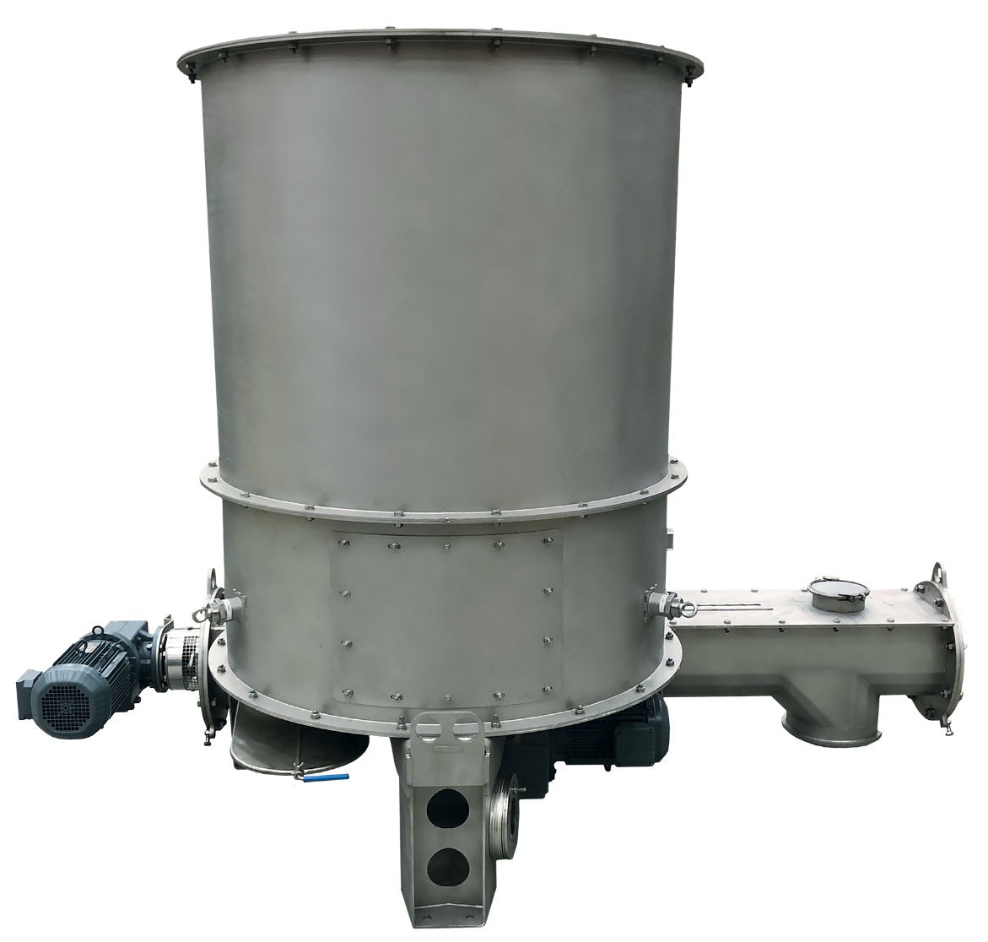
Open Area | FG/CE07 ─ The Coperion MechaTron FB Feeder has a flat bottom design, featuring vertical hopper walls and a bottom-driven agitator.
Photo: Coperion, Whitewater, WI, USA

