|  |  |
| --- | --- |
|  | **Contact**  Sarah Arnold  Marketing Communications  Herbold Meckesheim GmbH  Industriestraße 33  74909 Meckesheim/Deutschland  Telefon +49 (0)6226 932-0  sarah.arnold@herbold.com  www.coperion.com |
| Ein Bild, das Kugel, Ball, Kunst enthält.  KI-generierte Inhalte können fehlerhaft sein.  Hall 9 I Booth 9B34  FGCE07 I Open Area "The Power Of Plastics Forum"  Hall 14 I Booth 14B19 |
|  |
|  |

Press Release

**Herbold at K 2025**

**Herbold Meckesheim Unveils Cutting-Edge Recycling Solutions at K 2025**

*Meckesheim, Germany, July 2025* – Herbold Meckesheim, a brand of Coperion, will showcase its latest advancements in plastics recycling technology at K 2025, taking place from October 8 to 15 in Dusseldorf, Germany. Building on its long-standing expertise in modular system solutions for size reduction, washing, separation, drying, and agglomeration of plastics waste, Herbold Meckesheim offers tailored, highly automated plants for numerous industrial recycling applications. The company will present a range of integrated systems and solutions designed for mechanical processing, including the new high-capacity Mechanical Dryer T150-300 and the latest SMS granulator model. Visitors can explore these innovations firsthand at Hall 9, Booth 9B34. In addition, a Hydrocyclone Separation Stage will be showcased in the Coperion and Herbold Meckesheim Recycling Pavilion in the Open Area FG/CE07, where the companies will demonstrate their comprehensive interlocking recycling solutions. This participation highlights Herbold Meckesheim’s and Coperion’s ongoing commitment to delivering cutting-edge machinery and process solutions that drive the shift toward a more circular plastics economy.

**New Dryer: A Step Forward in Drying Technology**

Herbold’s latest innovation, the Mechanical Dryer T 150-300, debuts in a new size at K 2025 in Booth 9B34 in Hall 9. This high-capacity model sets new standards in large-scale drying applications, reaching throughputs of up to 2.5 tons of film per hour or >10t/h of PET or rigid flakes. The dryer features a fully redesigned construction, including a rotating sieve basket with integrated water spray nozzles for full-coverage cleaning and a centrifugal drying chamber for rapid moisture removal.

Designed for maintenance simplicity, it is equipped with hydraulically hinged housing for quick access and advanced monitoring systems supporting predictive maintenance. This innovative dryer is perfectly suited for demanding industrial workflows, particularly for film processing, ensuring consistent surface cleanliness and superior drying efficiency.

**Granulator: High-Performance Efficiency**

The next size of Herbold’s SMS Granulators, renowned for its durability and precision, will also be showcased at Hall 9. The SMS 80-200 Granulator is built for demanding applications. It integrates energy-efficient double cross-cutting action and pre-adjustable rotor and bed knives to produce a high-quality regrind with minimal fines and consistent particle size distribution. Its design emphasizes ease of maintenance, featuring a hinged housing and quick knife change system, ultimately reducing downtime and operational costs.

As the largest model in the series, the SMS 80-200 Granulator’s robust construction and forced feeding system—via three horizontally mounted screws—enables a high throughput of PET and rigid plastics, making it ideal for large-scale recycling operations.

The SMS series is optimized for a wide range of materials and ideal for the size reduction of standard applications in the recycling industry, as well as special processing needs—for example, heavy lumps, tough fibers, thin films, or substantial amounts of material.

**At the Recycling Pavilion: Hydrocyclone Stage - Integrating Precision Separation**

At Coperion and Herbold’s Recycling Pavilion in the Open Area (FG/CE07) a Herbold Hydrocyclone Separation Stage, a key component designed to deliver precise material separation through centrifugal forces, can be seen together with a Coperion ZSK FilCo filtration compounder. Herbold’s hydrocyclone stage enhances the purification of plastics during recycling, extending equipment lifespan and improving product quality.

The Hydrocyclone system, featuring a robust density separation, accommodates various application needs, providing additional washing and efficient impurity removal. The system includes capabilities for separating residual contaminants such as sand, glass, or metals using heavy medium cyclone technology and high-turbulence washing. The system includes also a friction washer which is capable to remove paper and other fiber contaminants.

**System Solution for PET Recycling: Seamless Integration**

Together, the Hydrocyclone Stage and the ZSK FilCo filtration compounder are exemplary exhibits that demonstrate how integrated Herbold and Coperion process modules produce high-quality recyclates. The ZSK FilCo recycling extruder system allows filtration and compounding in a single production step, and works in tandem with the Hydrocyclone Stage to deliver a complete, streamlined system for post-consumer recyclate (PCR) or any highly contaminated polymer reprocessing. This combination ensures the highest levels of purity and efficiency, meeting the stringent end product quality standards.

Additionally, visitors can find Coperion’s comprehensive compounding solutions in Hall 14, Booth 14B19.

**About Herbold Meckesheim**

Herbold Meckesheim ([www.herbold.com](http://www.herbold.com/)) is a leading recycling specialist and produces machines and plants for processing pure plastic waste from the industry as well as used, mixed and contaminated plastics. The modular system solutions for automated recycling lines are tested in the company's own technical center. More than 260 employees at the headquarters and the staff of the international agencies accompany custom-made plants and machines from the conception stage through commissioning to the end of their commercial use. Since 2022 Herbold Meckesheim is part of the Recycling Business Unit of Coperion, which offers complete solutions for plastics recycling processing. Coperion is the global industry and technology leader in compounding and extrusion systems, feeding and weighing systems, bulk material handling and services. Coperion is an Operating Company of Hillenbrand (NYSE: HI), an industrial company operating in over 40 countries serving a wide variety of industries across the world. [www.hillenbrand.com](http://www.hillenbrand.com/)



Dear Colleagues,  
You can find and download this press release in German and English as well as print-ready color images at

**https://www.coperion.com/en/news-media/newsroom/**

.

Editorial contact and copies:

Dr. Jörg Wolters, KONSENS Public Relations GmbH & Co. KG,  
Hans-Böckler-Str. 20, D - 63811 Stockstadt am Main, GERMANY  
Tel.: +49 (0)60 27/ 99 00 5-0  
E-Mail: mail@konsens.de, Internet: www.konsens.de

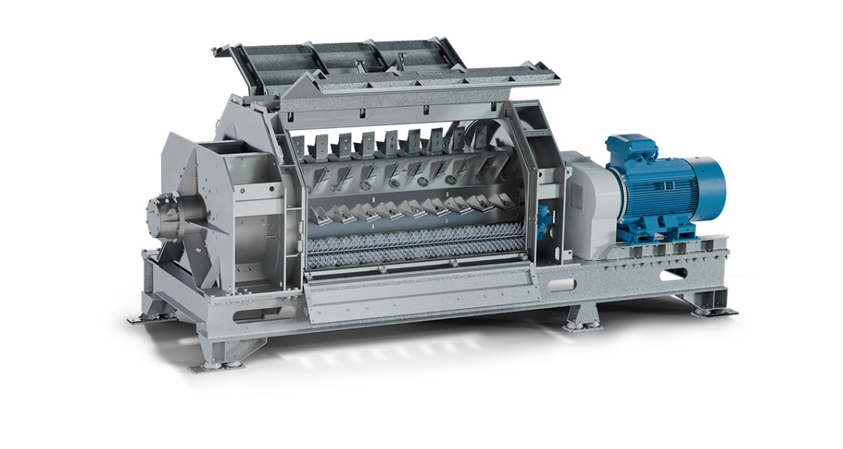

The new Mechanical Dryer T 150-300 sets standards in large-scale drying, featuring a rotating sieve basket with integrated water spray nozzles for comprehensive cleaning and rapid moisture removal.

*Image: Herbold Meckesheim, Germany*

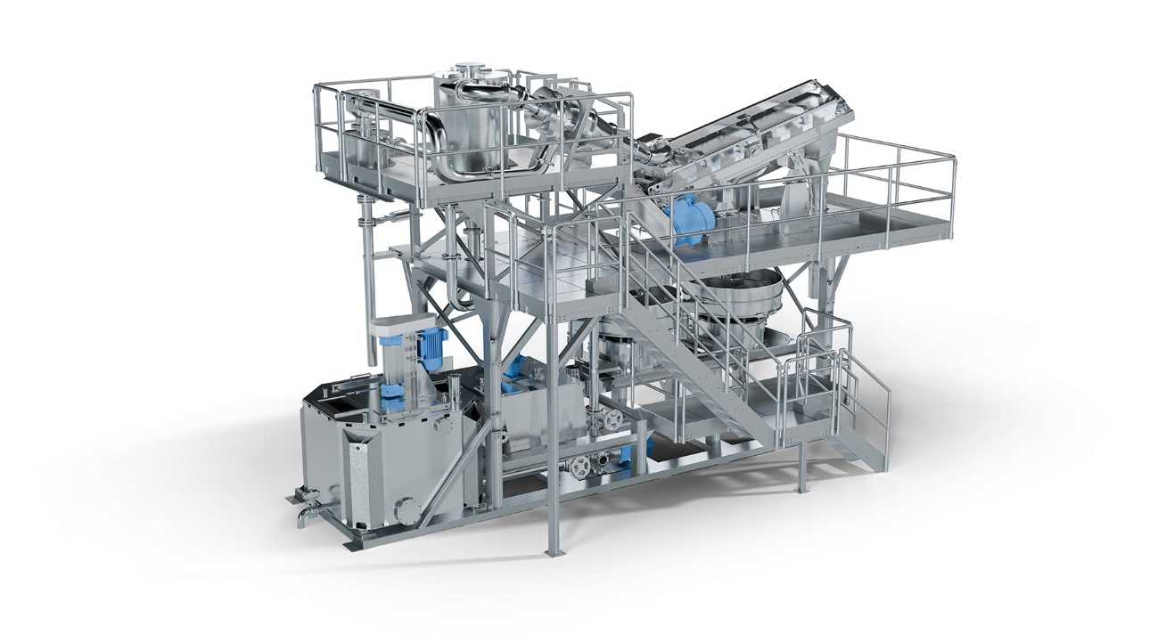

The Hydrocyclone Separation Stage uses centrifugal forces and turbowasher technology to accurately separate and purify plastic materials, enhancing recycling efficiency and material quality.

*Image: Herbold Meckesheim, Germany*

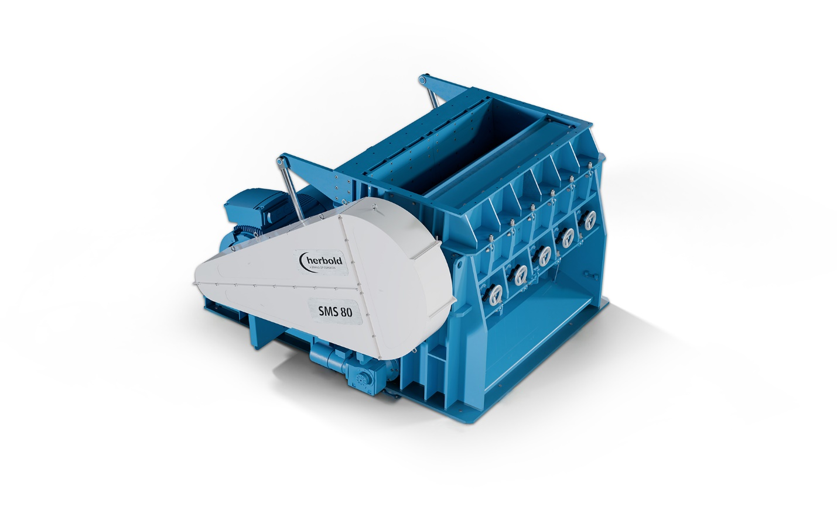

The SMS 80-200 Granulator, designed for demanding recycling processes, delivers high throughput with precise size reduction, minimal fines, and a quick knife change system for maximum operational efficiency.

*Image: Herbold Meckesheim, Germany*