**Contact**

Regula Sullivan

Marketing Communications

Coperion K-Tron (Switzerland) LLC

Lenzhardweg 43/45

CH-5702 Niederlenz

Tel: +41 62 885 7171

regula.sullivan@coperion.com

www.coperion.com

**Press Release**

**Coperion K-Tron Proud Supplier of High Accuracy Batch Feeders to Pfizer Germany High Containment Facility**

*Niederlenz, Switzerland (March 2025) -* Pfizer, a global leader in the pharmaceutical industry, chose to integrate high accuracy Coperion K-Tron feeders into its new high containment manufacturing plant in Freiburg, Germany. This completely automated production facility is designed to maximize the efficiency and productivity of Pfizer's pharmaceutical production processes, doubling drug production capacity while shortening production times.

The integration of Coperion K-Tron feeders into Pfizer's German facility underscores the pharmaceutical giant's commitment to leveraging cutting-edge technology to optimize its operations. This collaboration also demonstrates the growing importance of precise and reliable products in the pharmaceutical industry - characteristics that make Coperion K-Tron equipment stand out.

The state-of-the-art facility in Freiburg, Germany, houses over 2000 employees and has been built to supply tablets and capsules to over 185 countries. Current production includes 6.7 billion tablets and capsules annually. In addition, since the facility has the capability to handle highly potent OEB 4 compounds, all systems are completely enclosed and utilize split butterfly valve containment and drum dumping glove boxes for contained product transfer.

In this groundbreaking automated process, a variety of raw materials — including excipients and active pharmaceutical ingredients (APIs)—are delivered to the automated dispensing systems via drums, big bags or smaller bags and are then introduced to the Coperion K-Tron high accuracy K3 line of pharmaceutical feeders. The feeders then dose the specified amounts required for the batch as dictated by the specific formulation through an overall PLC based control system. All batch setpoints are communicated directly to each KCM feeder controller, which in turn controls the high accuracy loss-in-weight (LIW) batching of the feeder. This initial batch is then mixed and moved to another station where more LIW feeders accurately dose additives into the batch, before the mixture continues to the tablet press.

**Highly Accurate K3-PH Line of Pharmaceutical Feeders**

The Coperion K-Tron line of K3-PH feeders has been specifically designed to meet the growing demands of continuous and batch processing in the pharmaceutical industry. Due to the use of a smaller D4 platform scale, incorporating the highly accurate Smart Force Transducer (SFT) weighing technology, these feeders require significantly less floor space than previous models. The feeder’s modular quick change design allows the easy exchange of feeder sizes, using the same scale and drive for fast adaptation to new processes and formulations while also ensuring easy cleaning and maintenance. The quick change feeder bowl, agitator, and screw combinations can be quickly decoupled from the feeder drive, allowing for simple and fast changeover and cleaning of the feeders. The updated modular concept features a newly developed drive using a servo motor which helps reduce the overall footprint and offers a much larger turndown range, including low feed rates. For an optimal wash-in-place result, every unit has an integral 2-degree pitch, facilitating maximum drainage during the cleaning processes.

**High Precision Batch Accuracy with the New KCM-III Controller**

The KCM-III features a completely new, powerful CPU with extended memory and optimized control algorithms to ensure faster communication with the feeder drive, weighing system and peripherals. In combination with the latest generation of Smart Force Transducer (SFT) load cells, the KCM-III also offers a significantly higher weighing resolution of 8,000,000:1 in 20 ms. The latest generation of SFT load cells allow for even higher sampling rates at 450 samples per second. These higher rates result in better noise filtering as well as less weight shift under vibration. In addition, the optimized controls lead to better short-term feeding accuracy as the control system reacts quickly to changes in the system. In the pharmaceutical continuous manufacturing world, where traceability is becoming more and more important, the KCM-III automatically stores up to seven days of log and event files, as well as trace and process data.

The advanced and state-of-the-art automated batch dispensing system at this manufacturing facility in Freiburg will most certainly help to advance the production of groundbreaking medicines for a variety of applications. Coperion K-Tron’s complete line of equipment is engineered to meet the rigid requirements of the industry, including strict adherence to cGMP guidelines and standards as well as the use of FDA approved materials of construction.

**About** **Coperion**Coperion ([www.coperion.com](http://www.coperion.com)) is a global industry and technology leader in specialized equipment for the food and health industries. Coperion develops, produces, and services plants, machinery, and components for the food, pet food, baking, pharmaceutical, and cosmetics industries. Its brands – Baker Perkins, Bakon, Coperion K-Tron, Diosna, Gabler, Kemutec, Peerless, Shaffer, Shick Esteve, Unifiller, and VMI – are experts in ingredient automation, pre-dough systems, mixing, and depositing technologies. Coperion employs more than 5,000 people in its three divisions Performance Materials, Food, Health & Nutrition, and Aftermarket Sales & Service, and in its over 50 sales and service companies worldwide. Coperion is an Operating Company of Hillenbrand (NYSE: HI), a global industrial company that provides highly-engineered, mission-critical processing equipment and solutions to customers serving a wide variety of industries around the world. [www.hillenbrand.com](http://www.hillenbrand.com)



Dear colleagues,   
You can download this press release in German and English and the color photos in printable quality from the Internet at <https://www.coperion.com/en/news-media/newsroom/>

Editorial contact and voucher copies:

Dr. Jörg Wolters, KONSENS Public Relations GmbH & Co. KG,  
Hans-Kudlich-Straße 25, D-64823 Groß-Umstadt  
Tel.:+49 (0)60 78/93 63-0, Fax: +49 (0)60 78/93 63-20  
Email: mail@konsens.de, Internet: [www.konsens.de](http://www.konsens.de)

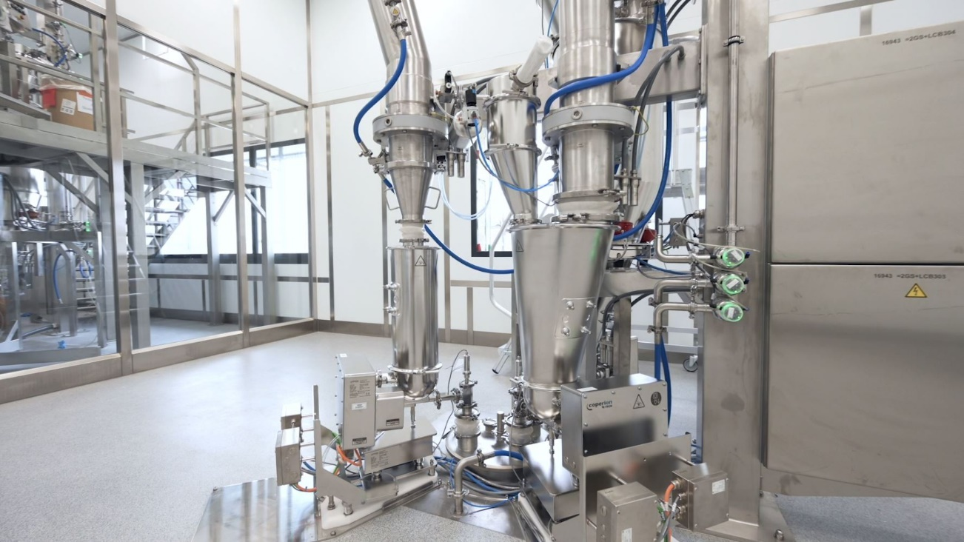

*Coperion K-Tron pharmaceutical feeders are an integral part of the Pfizer high containment automated production facility in Germany.*

*Image: Pfizer Manufacturing Deutschland, Freiburg, Germany*

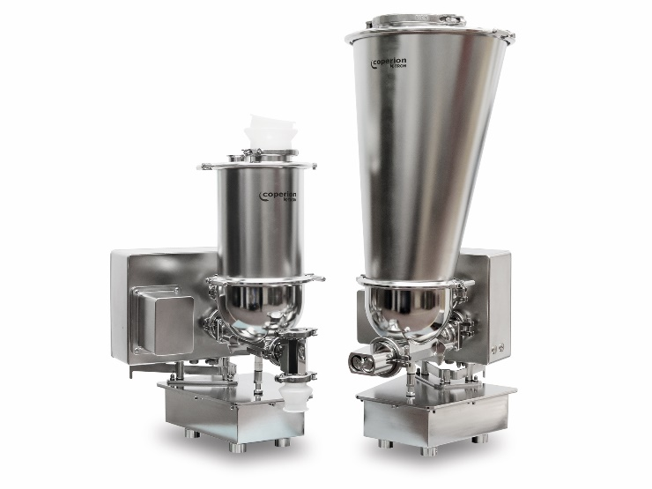

*Coperion K-Tron’s pharmaceutical feeder with a redesigned trapezoid scale shape and significantly smaller footprint is optimized for multi-feeder clusters around a process inlet.*

*Image: Coperion K-Tron, Niederlenz, Switzerland*