|  |  |
| --- | --- |
|  | **Contact**  Bettina König  Marketing Communications  Coperion GmbH  Theodorstraße 10  70469 Stuttgart/Germany  Telephone +49 (0)11 897 2215  bettina.koenig@coperion.com  www.coperion.com |
|  |
|  |
|  |

Press Release

**Coperion anniversaries**

**Celebrating 280 Years of Material Handling Leadership**

*Stuttgart, September 2025* – Coperion celebrates a remarkable series of anniversaries this year that highlight its long-standing commitment to innovation, expertise, and customer success. The company’s material handling business in Weingarten, Germany, and its feeder and conveying manufacturing facility in Niederlenz, Switzerland, both reach an impressive 125 years of operation, while Coperion Ideal in Noida, India, marks its 30th anniversary. Together, these milestones total an extraordinary 280 years of combined experience, know-how, and dedication to advancing the industry.

**Coperion’s material handling business boasts 125 years of deep bulk material handling know-how and expertise**

For 125 years, Coperion’s material handling business in Weingarten, Germany, has been a recognized leader in the bulk material handling markets. Like many companies at the turn of the last century, Coperion’s predecessor Waeschle initially ventured into the food industry, specializing in pneumatic conveying of grain and flour. It was only with the rise of plastics in the 1950s that new opportunities emerged, expanding the company’s horizons.

Today Coperion’s portfolio extends beyond its historical roots to include extensive process know-how and expertise in handling over 20,000 bulk materials and various methods for their efficient conveying, homogenizing, separating, heating and cooling methods. Plant engineering and design for large petrochemical installations as well as turnkey systems for the compounding industry are at the core of the company. Another key aspect of the company’s offerings is the design and manufacture of essential components such as rotary valves, diverter valves, and slide-gate valves, tailored for various industries. Complementing these products are Coperion’s process knowledge, engineering excellence, and project management capabilities, which allow the company’s experts to develop and deliver state-of-the-art bulk material handling systems for clients worldwide.

**Providing customers with high-accuracy innovative feeding solutions for 125 years**

Coperion K-Tron in Niederlenz, Switzerland, was established around the same time as Coperion Weingarten, also in the bakery industry, originally manufacturing grain milling equipment under the name J. Soder Company. Over the past 125 years, the company expanded its expertise and product portfolio and has consistently set industry standards in feeding technology, pioneering numerous advances and playing a significant role in the development of material handling and weighing systems. Today, Coperion K-Tron is renowned for providing sophisticated, state-of-the-art process equipment across a variety of industries and applications. Its innovative know-how is reflected not only in its advanced feeding and pneumatic conveying components but also in comprehensive material handling systems tailored to meet diverse customer needs worldwide.

Coperion K-Tron’s history is distinguished by numerous industry firsts, including the development of the first volumetric feeder in the early 20th century, the introduction of the first twin screw feeder in the 1950s, the creation of highly accurate digital weighing technology in the 1970s, and the launch of the revolutionary SmartConnex control system in 2003, among other innovations. These milestones have helped shape the feeding technology industry and have established Coperion K-Tron’s reputation as a trusted partner for companies worldwide.

**Coperion India celebrates 30 years**

Coperion Ideal, India, marks its 30th anniversary this year. Founded in 1995 as a joint venture in Noida to support the growing Indian petrochemical industry with plants, systems and components, the company exemplifies the philosophy of “we are where our customers are”. Today, Coperion Ideal is a complete solution provider for bulk material handling as well as additive unloading and feeding systems with in-house capabilities including design, engineering, project management, manufacturing, supply chain and service. Serving the Indian and Southeast Asian markets, the company plays a vital role in Coperion’s global organization.

30 years ago Managing Director Umesh Verma joined hands with Coperion’s predecessor Waeschle to create a manufacturing facility in Noida, India, to produce components such as slide gate valves, diverter valves and pressure vessels.

Over the years, the company has significantly enhanced its capabilities, building lasting trust and strong relationships across the industry. Committed to its strategic vision of making a meaningful difference, Coperion Ideal has continually expanded its product portfolio. The company now offers a comprehensive range of bulk material handling solutions.

Ulrich Bartel, President and CEO, Coperion says “This year, we proudly celebrate a remarkable milestone in our company's history — three anniversaries reflecting our enduring commitment to excellence in material handling. Coperion’s material handling business is officially 125 years young, and our feeding competence shares the same venerable milestone. Additionally, Coperion India marks its 30th anniversary of innovation and growth.”

Markus Parzer, President Performance Materials Division, Coperion, states: “Altogether, these anniversaries total 280 years of unparalleled experience, innovation, and dedication that have continually driven our success across the globe. These achievements are a testament to the hard work, ingenuity, and passion of our talented teams in every corner of our organization. Our commitment remains unwavering — to deliver cutting-edge solutions that empower our customers and advance the industry.”

**About Coperion**Coperion ([www.coperion.com](http://www.coperion.com)) is a global industry and technology leader in compounding and extrusion systems, size reduction, washing, separating, drying, agglomeration, feeding, weighing, material handling and pneumatic conveying systems, as well as milling, mixing, thermal processing, dust collection and other services. Coperion develops, produces, and services plants, machinery, and components for the plastics and plastics recycling, chemical, battery, minerals, food and pharmaceutical industries. Coperion employs more than 5,000 people in its three divisions, Performance Materials, Food, Health & Nutrition, and Aftermarket Sales & Service - at over 50 sales and service locations worldwide. Coperion is an Operating Company of Hillenbrand (NYSE: HI), a global industrial company that provides highly-engineered, mission-critical processing equipment and solutions to customers serving a wide variety of industries around the world. [www.hillenbrand.com](http://www.hillenbrand.com)



Dear Colleagues,  
You can find and download this press release in German and English and print-ready color images at

**https://www.coperion.com/en/news-media/newsroom/**

.

Editorial contact and copies:

Dr. Jörg Wolters, KONSENS Public Relations GmbH & Co. KG,  
Hans-Böckler-Str. 20, D - 63811 Stockstadt am Main, GERMANY  
Tel.: +49 (0)60 27/ 99 00 5--0  
E-Mail: mail@konsens.de, Internet: [www.konsens.de](http://www.konsens.de)

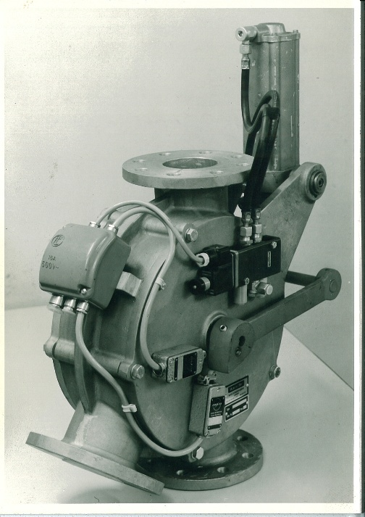

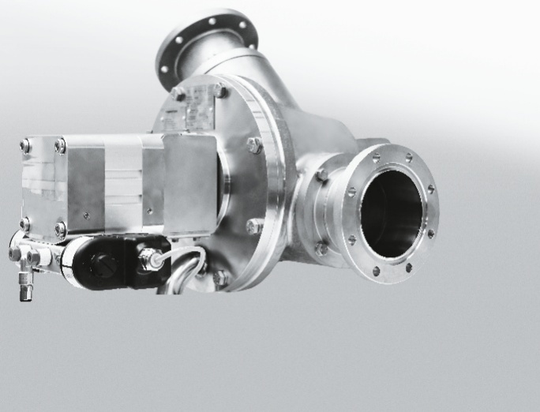

Historical and new diverter valves for bulk material handling.

Photo: Coperion, Weingarten/Germany

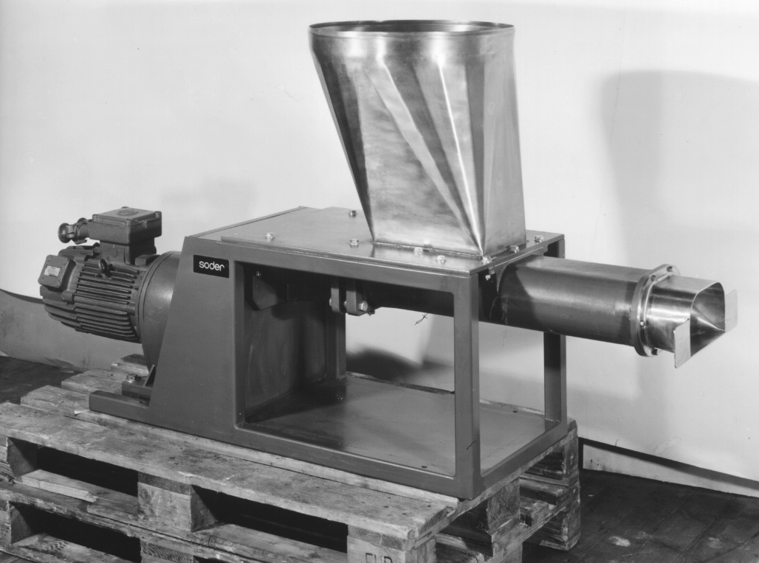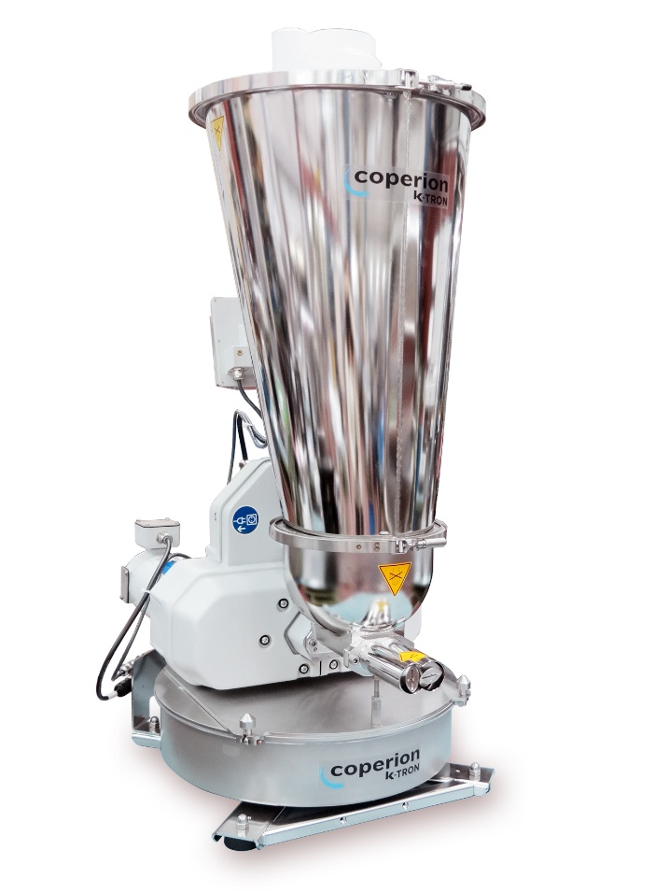

Coperion K-Tron Twin Screw Feeder 1966 and today.

Photo: Coperion K-Tron, Niederlenz, Switzerland