Contact
Kathrin Fleuchaus
Marketing Communications
Coperion GmbH
Theodorstraße 10
70469 Stuttgart/Germany

Telephone +49 (0)711 897 25 07
kathrin.fleuchaus@coperion.com
www.coperion.com
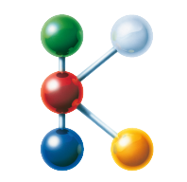

Hall 14 Booth 14B19
Hall 9 Booth 9B34
FG/CE07 I Open Area "The Power Of Plastics Forum"

Press Release

Coperion at K 2025
ZSK and STS Twin Screw Extruders: More Efficiency in Compounding and Recycling
Stuttgart, September 2025 – The central focus of Coperion's research and development work in the field of twin screw extrusion is increasing efficiency. Paths to greater efficiency in compounding and recycling will also be the focus of Coperion's appearance at K 2025. At Booth 14B19 in Hall 14, Coperion will exhibit a ZSK 58 Mc¹⁸ twin screw extruder. This model, with a 58 mm screw diameter, achieves throughputs of up to 2,500 kg/h with low energy consumption and a high degree of automation. Additionally, Coperion will display an STS 35 Mc¹¹ twin screw extruder at the same booth; this model has been specially optimized for masterbatch manufacturing. At the Recycling Pavilion FG/CE07 in the Open Area, Coperion will exhibit the added value of its twin screw extruders for recycling plastics. Coperion’s patent-pending ZSK FilCo filtration compounder will be on view there.
ZSK and STS: Proven high-performance extruders
Both Coperion’s ZSK and STS twin screw extruders excel with their high performance. Both series possess a very high specific torque – that of the ZSK Mc¹⁸ is 18 Nm/cm³; on the STS Mc¹¹ it is 11.3 Nm/cm³. The torque is directly transferred via the gearbox and the screw shafts onto the rotating twin screws in the process section, making it possible to achieve very high throughputs economically and energy-efficiently when processing products with torque requirement. Moreover, depending on the high filling level in the process section, the compound quality is outstanding. Together with both extruder series’ high level of automation, the costs per kilo of compound produced is comparatively low, and the return on investment is quickly reached. The extruders are very robust and reliable, and both machine availability and OEE (Overall Equipment Effectiveness) value are extremely high.
Coperion is exhibiting the ZSK 58 Mc¹⁸ with new screw elements that Coperion has developed especially for processing fillers. These reduce wear in the melt zone while simultaneously increasing throughput.
The STS 35 Mc¹¹ presented at the show is especially well suited for the production of masterbatches. It achieves throughputs of up to 300 kg/h. The closely intermeshing twin screws allow for an absolutely even distribution of the ingredients while ensuring effective self-cleaning in the process section. The compact design as well as the smooth machine surfaces make cleaning and maintenance during recipe changes very easy. The STS 35 Mc¹¹ stands out with very high process reliability and an attractive price-to-performance ratio. It will be exhibited with a Coperion AccuRate® Series 602 volumetric feeder.
C-BEYOND Lifecycle Manager: Predictive maintenance for Coperion extruders
Coperion has expanded its C-BEYOND digital platform for capturing and displaying extruders’ operation data. C-BEYOND makes decisive key performance indicator (KPI) evaluations such as availability, production output, and product quality, available in real time. The production process is documented in detail and both energy consumption and CO₂ emissions per kilo of compound produced are calculated. In the Overall Equipment Effectiveness (OEE) tool, a line's efficiency is represented in real time, allowing the operator to react quickly to deviations.
New to C-BEYOND is the Lifecycle Manager, a component that enables predictive maintenance planning, thus increasing a line's OEE. In the Lifecycle Manager, upcoming maintenance and repair tasks are computed for all components of a Coperion extruder, based upon operating hours and performance, and reports them in advance. For example, if service on the gearbox is coming up soon, C-BEYOND triggers a notification.
Servicing and maintenance work can be easily bundled using the Lifecycle Manager and scheduled proactively to minimize the impact on the Coperion extruders’ high productivity. Following successful execution, any service measure is documented in C-BEYOND and is viewable at any time, along with a report. Thus, for every equipment, an extensive maintenance history is generated over the years of a machine's life.
The Lifecycle Manager has already proven itself in practice on several pilot machines. Coperion customers have been able to improve their machines’ OEE significantly with this new tool.
Condition Monitoring: Real-time operating condition of ZSK extruders
Coperion is exhibiting its new extruder condition monitoring system at K on the ZSK 58 Mc¹⁸. With the aid of sensors on the motor, gearbox and process section, this system continuously monitors vibrations in the extruder and the gearbox's oil condition. The first anomalies in operation are detected early. Within a service agreement, Coperion remotely assumes monitoring and evaluation of the captured data and provides recommendations for action, allowing service measures to be conducted proactively and minimizing unplanned downtimes. The condition monitoring system can be integrated into both new and existing machines and has proven its reliability in numerous applications.
ZSK Recycling Extruder: Recompounds of high product quality
In the Open Area at the Recycling Pavilion FG/CE07, Coperion will demonstrate that the ZSK extruder is suited not only for compounding but also for plastics recycling. In contrast to single screw extruders widely used in plastics recycling, the ZSK twin screw extruder stands out with its very intensive mixing properties, its strong devolatilization performance and the high mechanical energy input that makes short residence times in the process section possible. Product processing is very energy efficient and gentle. Excellent product qualities in recycling of post-consumer and post-industrial waste are achieved while reaching high throughputs of up to 25 t/h.
These results have been demonstrated, for example, in recycling expandable polystyrene (EPS). The ZSK twin screw extruder produces first-class EPS quality – in the manufacturing process, up to 30% waste material can be added without compromising end product quality. Similar results have been achieved with PET recycled on Coperion’s bottle-to-bottle lines and condensed in an SSP (solid state polycondensation) reactor – a process which has been approved for direct contact with food by both the European Food Safety Administration (EFSA) and the U.S. Food and Drug Administration (FDA), as well as having been brand owner approved. One of Coperion’s bottle-to-bottle reference facilities achieves throughputs of 6500 kg/h using a ZSK 133 Mc¹⁸. Throughput rates of up to 10 t/h are possible with this Coperion solution. With the ZSK FilCo, Coperion will be exhibiting a particular design of its recycling extruders: this is filtration compounder allows for recyclate filtering and compounding in a single process step. The space requirement compared to that of two-step production lines is markedly less. The waste plastic is melted only once, thus ensuring very energy-efficient, high compound quality.

About Coperion
Coperion (www.coperion.com) is a global industry and technology leader in compounding and extrusion systems, size reduction, washing, separating, drying, agglomeration, feeding, weighing, material handling and pneumatic conveying systems, as well as milling, mixing, thermal processing, dust collection and other services. Coperion develops, produces, and services plants, machinery, and components for the plastics and plastics recycling, chemical, battery, minerals, food and pharmaceutical industries. Coperion employs more than 5,000 people in its three divisions, Performance Materials, Food, Health & Nutrition, and Aftermarket Sales & Service - at over 50 sales and service locations worldwide. Herbold Meckesheim is a brand of Coperion. Coperion is an Operating Company of Hillenbrand (NYSE: HI), a global industrial company that provides highly-engineered, mission-critical processing equipment and solutions to customers serving a wide variety of industries around the world. www.hillenbrand.com



Dear Colleagues,
You can find and download this press release in German, English and Chinese and print-ready color images at
https://www.coperion.com/en/news-media/newsroom/
.

Editorial contact and copies:
Dr. Jörg Wolters, KONSENS Public Relations GmbH & Co. KG,
Hans-Böckler-Str. 20, D - 63811 Stockstadt am Main, GERMANY
Tel.: +49 (0)60 27/ 99 00 5-0
E-Mail: mail@konsens.de, Internet: www.konsens.de

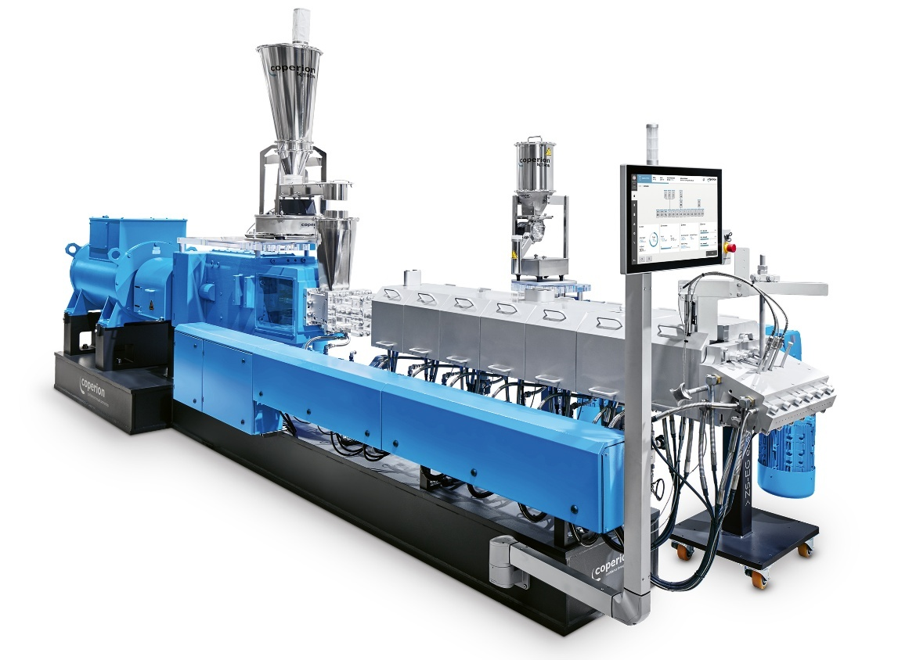
In compounding and recycling, the Coperion ZSK 58 Mc¹⁸ twin screw extruder delivers excellent product quality and extremely high throughputs because of its numerous innovative features.
Photo: Coperion, Stuttgart Germany

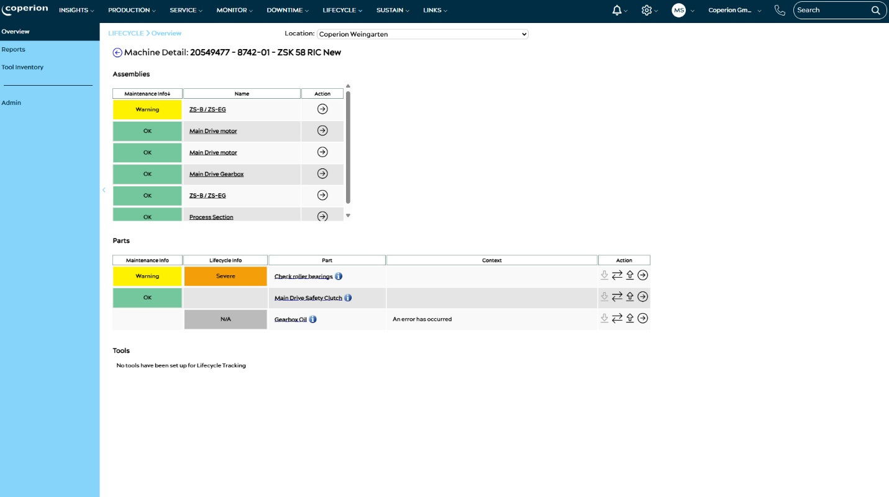
Coperion has expanded its digital C-BEYOND platform to include the new Lifecycle Manager, which provides advance notice for upcoming maintenance tasks on all components of a ZSK extruder.
Photo: Coperion, Stuttgart Germany

