Press Release

Coperion Elevates Customer Experience with Enhanced Brand Identity and Unified Technology Solutions
Kansas City, May 19, 2025 – Coperion is excited to announce a significant evolution in its brand identity that aims to enhance the experience for its customers, employees and wider stakeholders. As the company continues to elevate its esteemed Food, Health and Nutrition division brands — Baker Perkins, Bakon, Coperion K-Tron, DIOSNA, Gabler, Kemutec, Mucon, Peerless, Shaffer, Shick Esteve, Unifiller, and VMI — Coperion is further unifying its operations through strategic branding changes.
With a refreshed and invigorating new visual identity, including updated, synergized technology logos within a cohesive branding system, Coperion reinforces its commitment to quality and innovation. The newly enhanced brand visuals position them as ‘brands and technologies of Coperion,’ maintaining the company’s extensive experience and expertise provided through these brands. This ensures customers continue to benefit from an integrated approach of complete process solutions for end products.
This branding update is also designed to reflect Coperion's ability to provide a comprehensive offering tailored to meet and exceed specific customer needs.
Coperion’s dedicated teams serving customers will remain unchanged and are firmly committed to ensuring customer success and strengthening partnerships.
Moving forward, Coperion will showcase its technology brands with the logos displayed below:
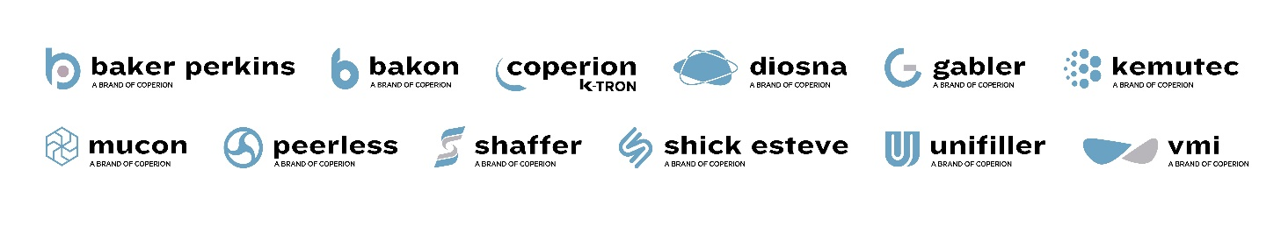
Coperion expresses its gratitude for the support received as the company embarks on this exciting brand enhancement journey.
For more information, please contact:
communications@coperion.com

About Coperion
Coperion (www.coperion.com) is a global industry and technology leader in specialized equipment for the food and health industries. Coperion develops, produces, and services plants, machinery, and components for the food, pet food, baking, pharmaceutical, and cosmetics industries. Its brands – Baker Perkins, Bakon, Coperion K-Tron, Diosna, Gabler, Kemutec, Peerless, Shaffer, Shick Esteve, Unifiller, and VMI – are experts in ingredient automation, pre-dough systems, mixing, and depositing technologies. Coperion employs more than 5,000 people in its three divisions Performance Materials, Food, Health & Nutrition, and Aftermarket Sales & Service, and in its over 50 sales and service companies worldwide. Coperion is an Operating Company of Hillenbrand (NYSE: HI), a global industrial company that provides highly-engineered, mission-critical processing equipment and solutions to customers serving a wide variety of industries around the world. www.hillenbrand.com

